# Georgia Bar and Florida Bar Script

Step 1: Install Python.

Go to Python.org

Click on Downloads.

Download Python 3.8.0 for Windows. If you’re using XP, we can no longer be friends.

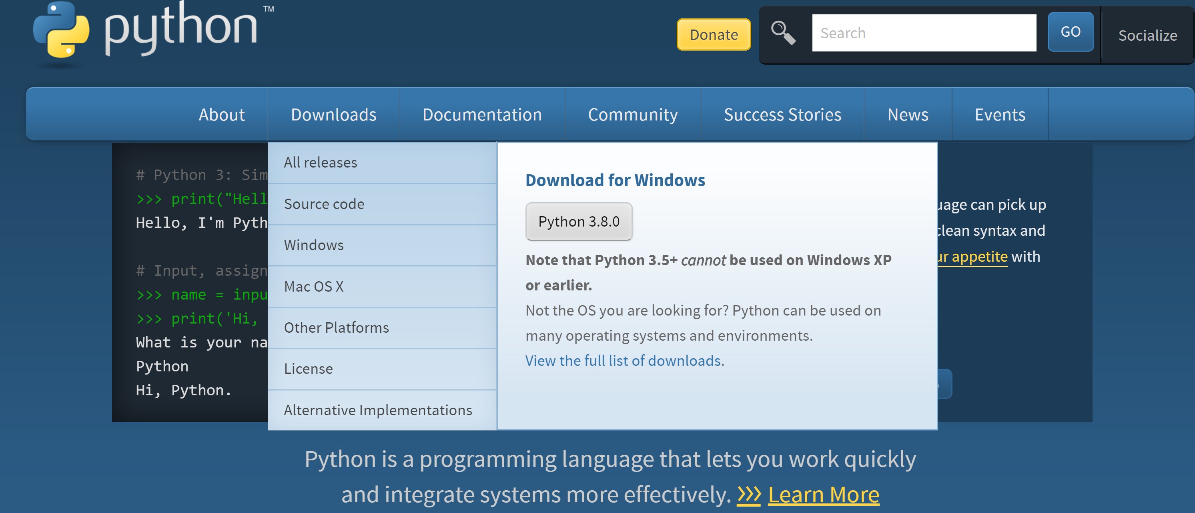

Step 2: Install Tapermonkey Chrome Extension. This must be installed for the script to work. The Georgia Bar hides their URL and this solves the problem.

Click here to install the Tapermonkey Chrome Extension while using a Chrome Browser. <https://chrome.google.com/webstore/detail/tampermonkey/dhdgffkkebhmkfjojejmpbldmpobfkfo?hl=en>

Step 3: Once Tapermonkey is installed on your Chrome Browser, it will look like this on the upper right corner. Find the icon with the black square and two eyes.   
Click on it and then click on “Create a New Script”.

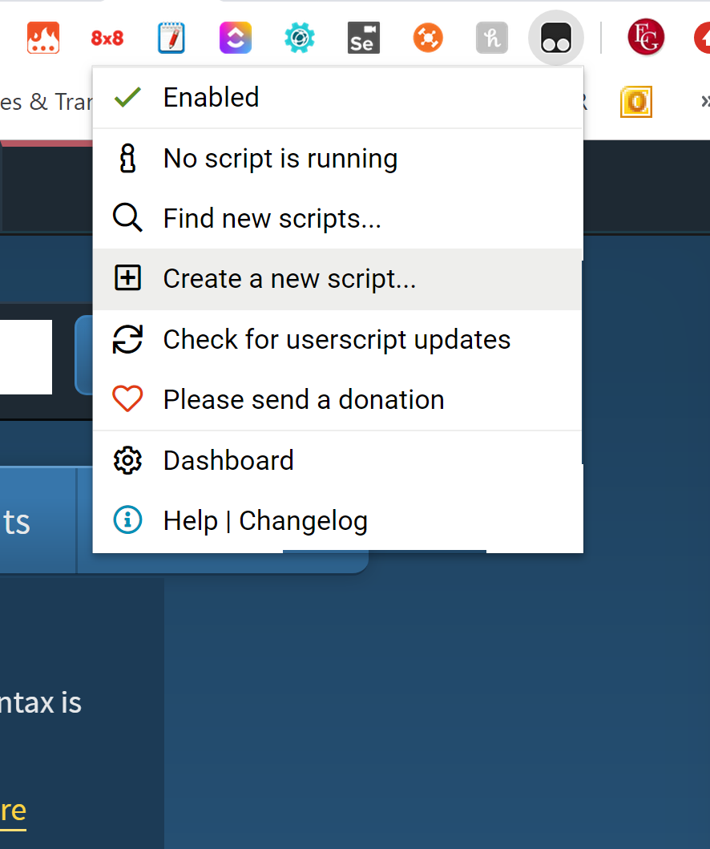

Step 4: Open the file called gabar.js Select Open with Notepad to open as a text file.

Right click and select “open with” Notepad.

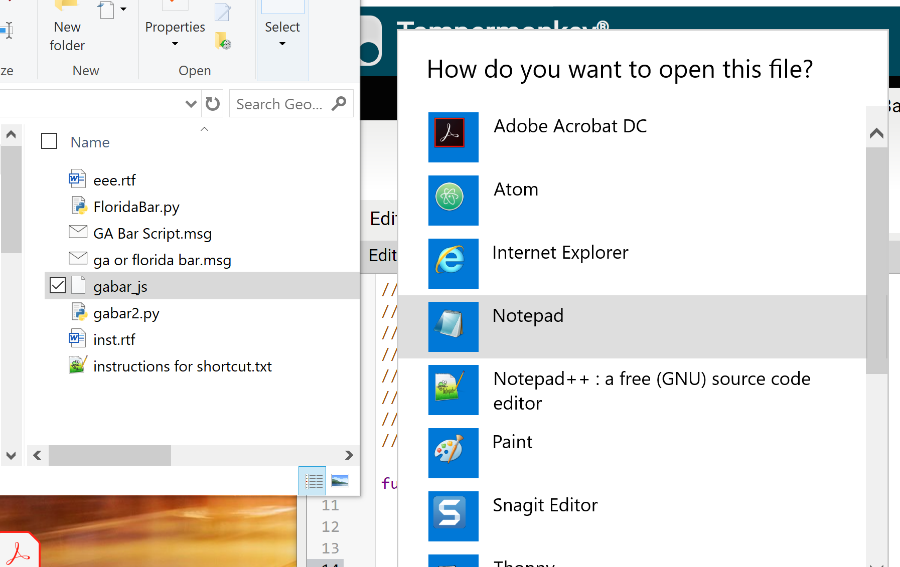

Step 5: Copy the ENTIRE contents of the text file into the Tapermonkey new script. Be sure to overwrite the sample text.

Save and close when you are done. It will look like this:

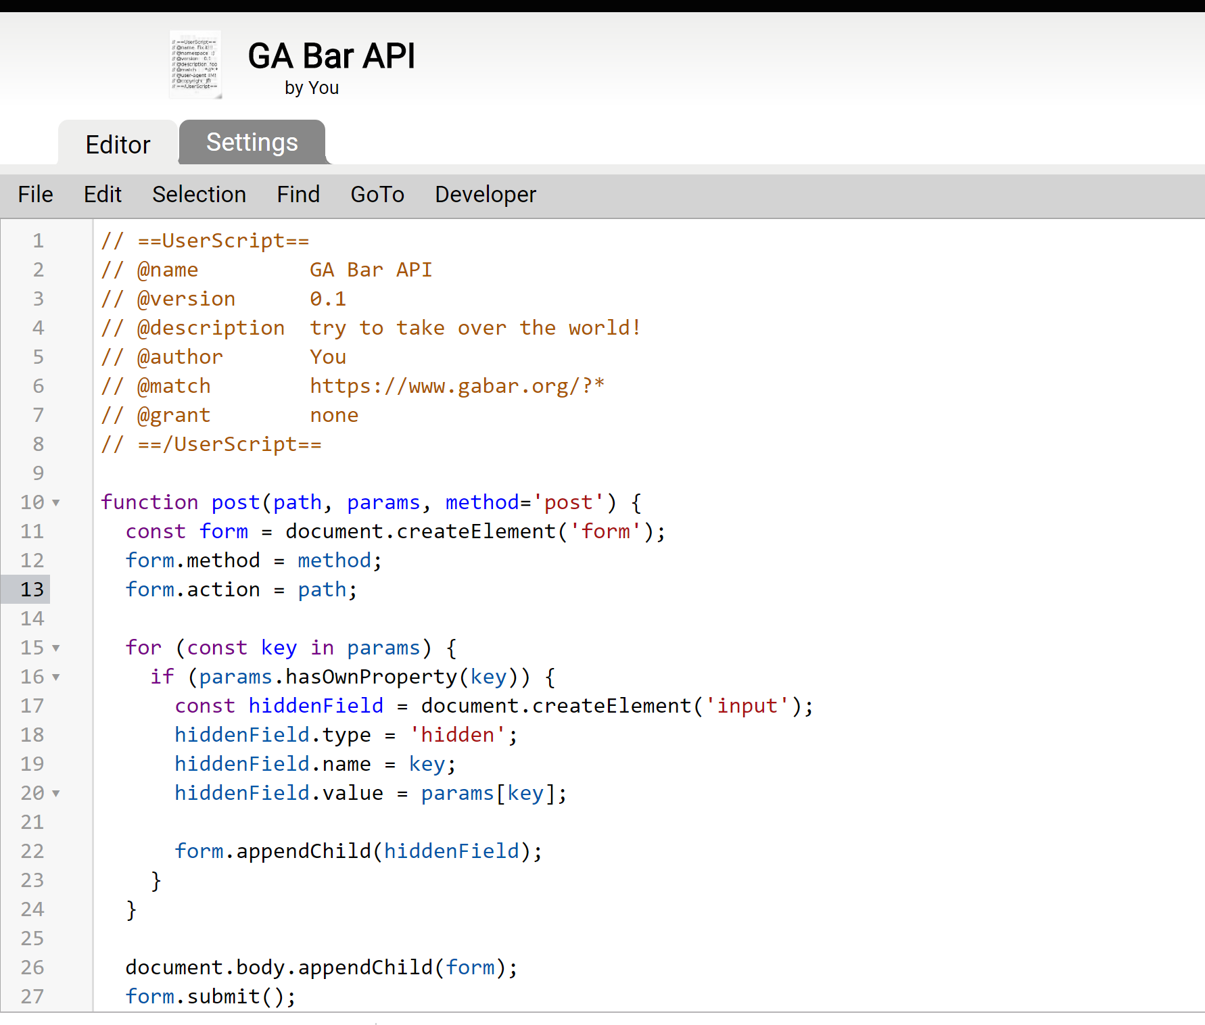

Step 6: Close your Tapermonkey Chrome Browser.

Step 7: Highlight the red name and copy (Control-C) this name only: **Foss Baker**

Step 8: Now click on the file called gabar2.py. This should open the Georgia Bar website and find the attorney.

Step 9: Highlight the red name only and copy (Control0C) this name only: [**Aaron Robert Baker**](https://www.floridabar.org/directories/find-mbr/profile/?num=50345)

Step 10: Now click on the FloridaBar.py file

This will test that the scripts are running. If you run into issues, call Elizabeth.   
Proceed further to create hotkeys so the scripts will run using key combinations.

Step 11: Go to File Explorer Options. On your PC click on the Magnifying Glass Search on the bottom left and type “File Explorer Options”.

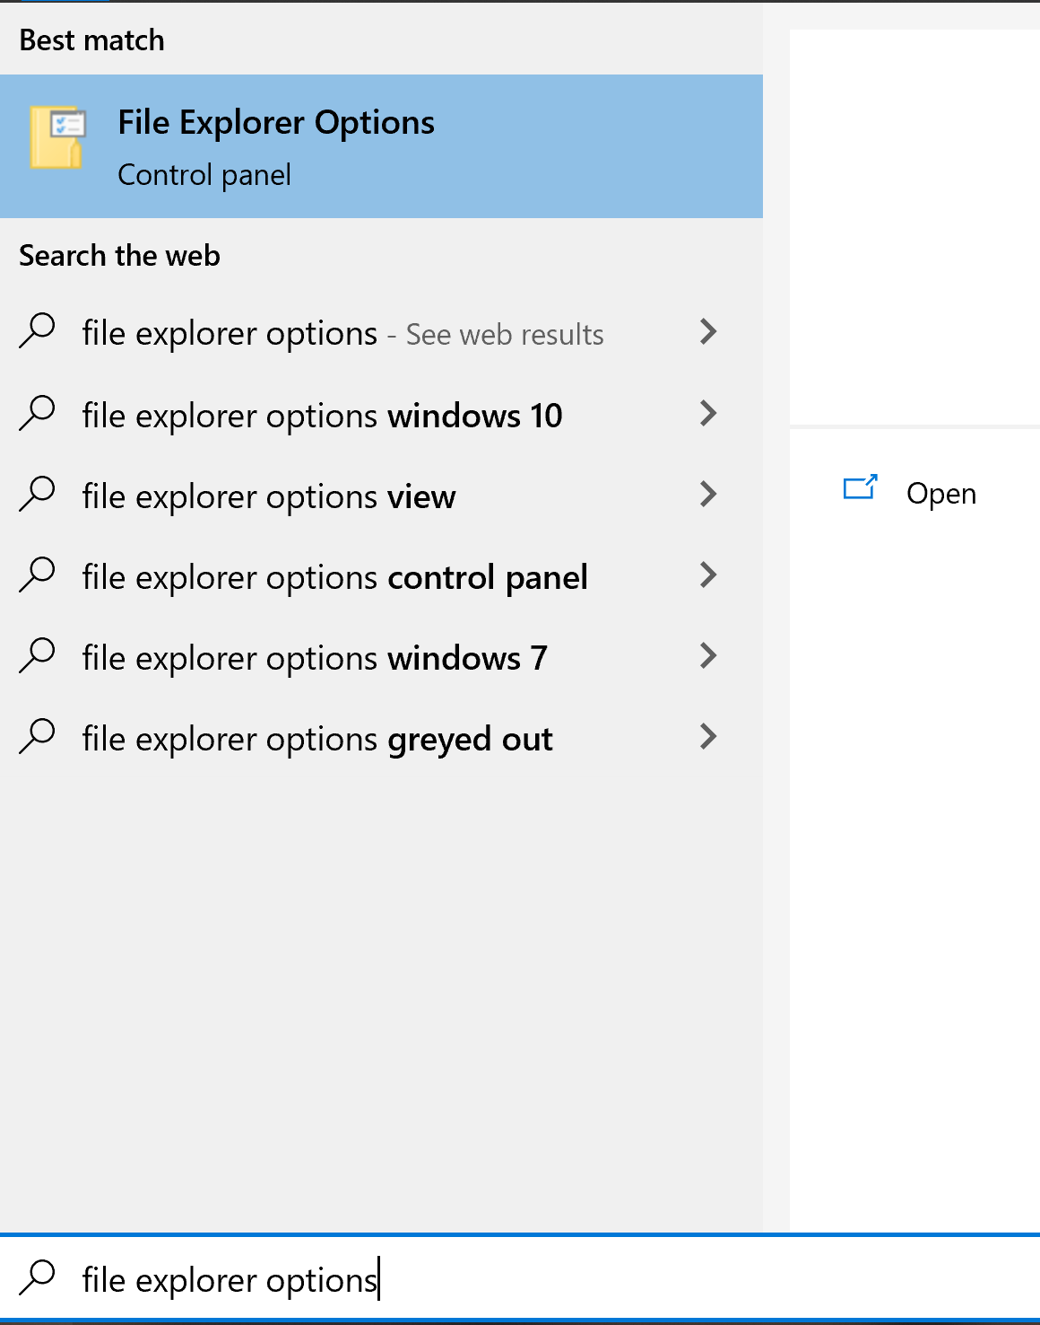

Step 12: Click on File Control Options Control Panel.

Step 13: Click on View Tab and Scroll down. Uncheck "Hide protected Operating system files" and **click** on "**Show** hidden files and **folders**"

**Press** Yes and then OK. Close this window.

Step 14: Go to your C Drive > Program Files. Then click “New Folder”  
Step 15: Name folder EG Programs

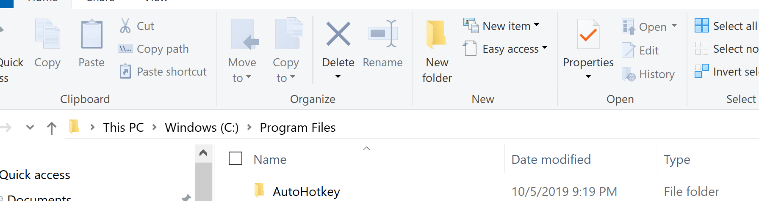

Step 16: Put gabar2.py and FloridaBar.py in the folder you just created called EG Programs. Yes through any prompts. You will need to give admin access.

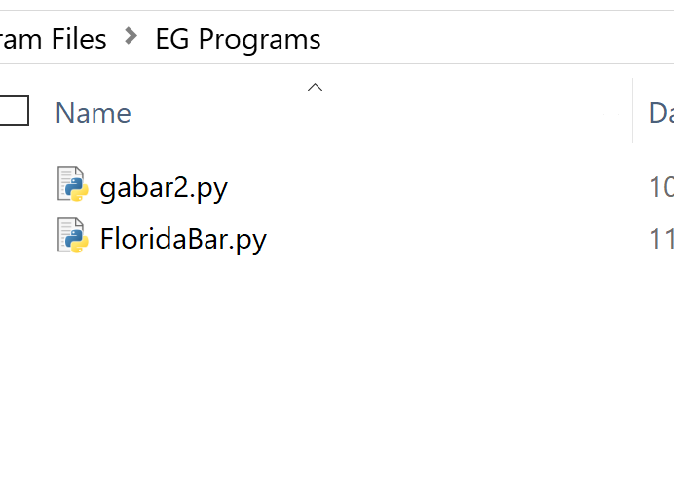

Step 17: Highlight both files and right click and select Create Shortcut. It will prompt you to put the shortcuts on your desktop. Go ahead and do that. You will move them later.

Close this folder.

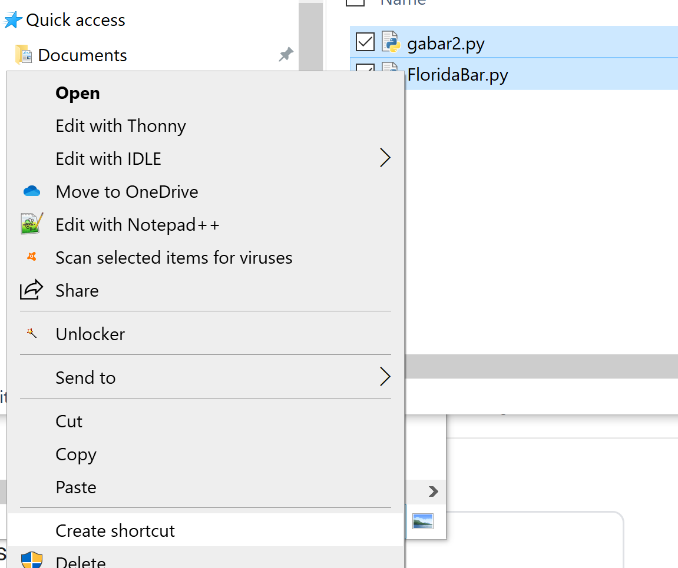

Step 18: Now you will need to move the two shortcuts you made into Program Data. Be careful not to change any files in this folder.

Step 19: Carefully follow this path to move the shortcuts into this folder. You don’t want to copy. You want to move them.

On your PC, go to this path: C: > ProgramData > Microsoft > Windows > Start Menu > Programs

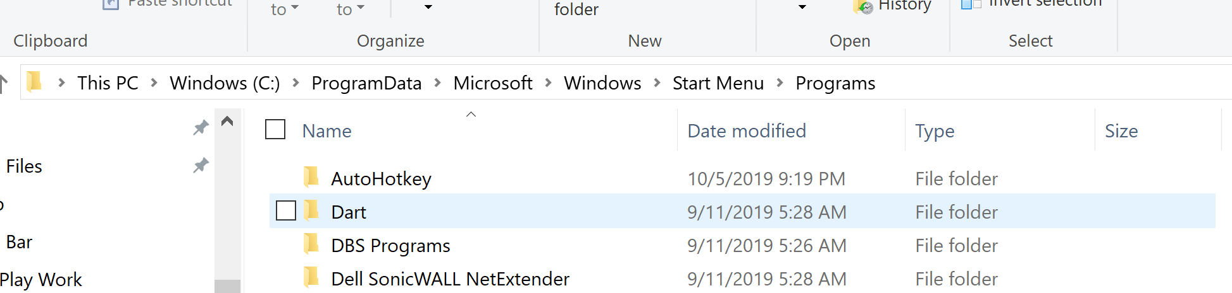

Step 20: Once in this path, MOVE the two shortcuts on your desktop with the .py scripts to this folder. Yes past any admin access.

Step 21: Right Click on each script and select properties.

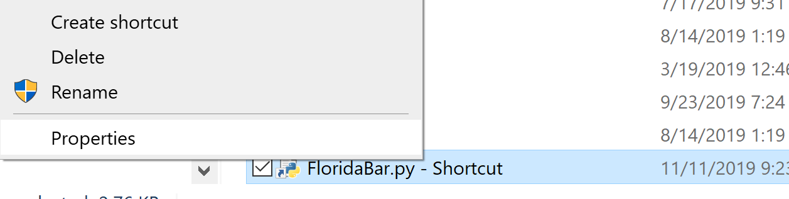

Step 22: Go to the Shortcut tab. Where it says “Shortcut key”, type F for Florida script .

Be sure to click APPLY and then okay. Click Continue to give admin access.

Step 23: Repeat Step 22 with the GaBar2.py script and assign the shortcut G for Georgia script.

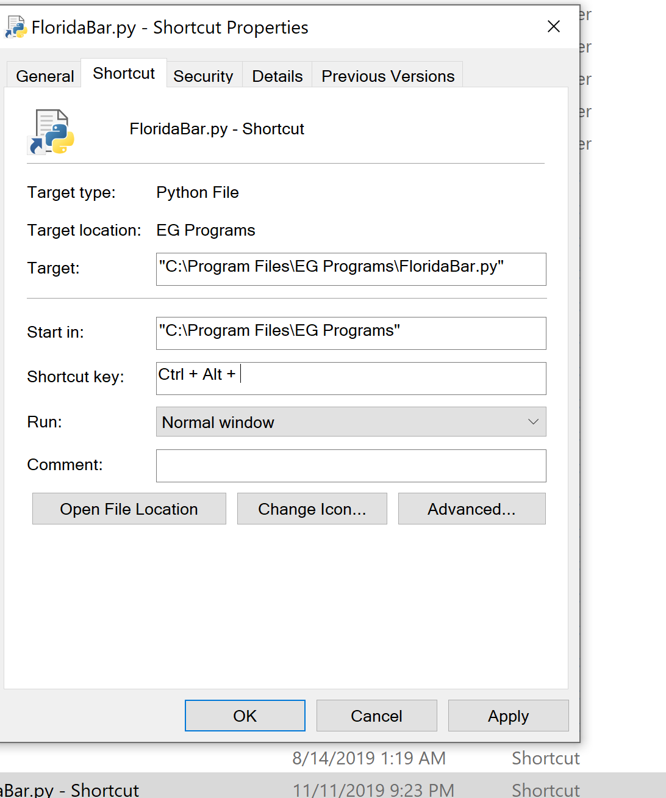

Step 24: Now test it out.

Highlight the red name and copy (Control-C) this name only: **Foss Baker**

**Now click Control + Alt + G**

Highlight the red name only and copy (Control-C) this name only: [**Aaron Robert Baker**](https://www.floridabar.org/directories/find-mbr/profile/?num=50345)

**Now click Control + Alt + G**

NOW FROM ANY NOTICE THAT YOU CAN COPY, ANY WORD DOC, ANY TRANSCRIPT, HIGHLIGHT THE ATTORNEY’S NAME, CLICK CONTROL-C AND CONTROL+ALT+G AND GEORGIA BAR WILL PULL UP AUTOMATICALLY.